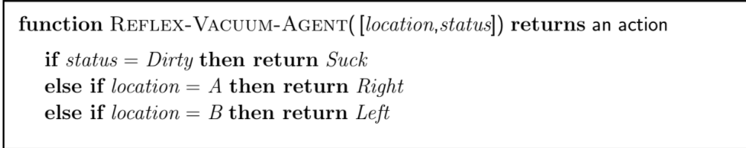**Vacuum cleaner Simple Reflex Agent:**

**Rational Agent:**

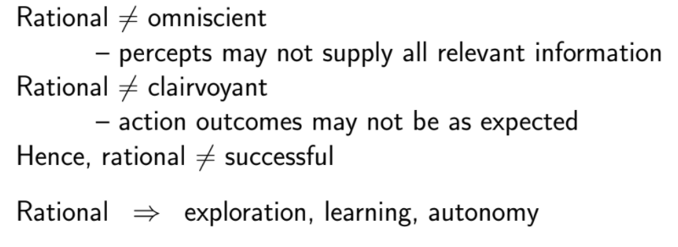

**Omniscient:**  Knowing everything.

**Clairvoyant:**  Predicting future based on the past actions.

**Autonomy:**

**Task Environment: (PEAS):**



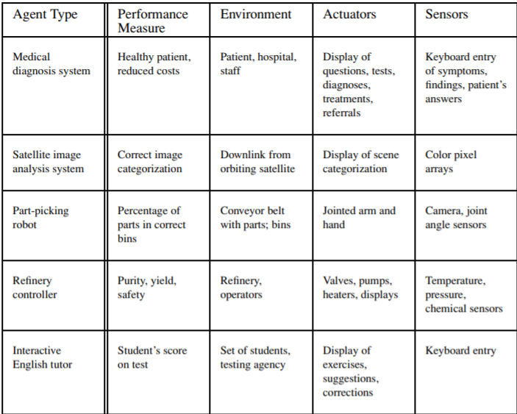

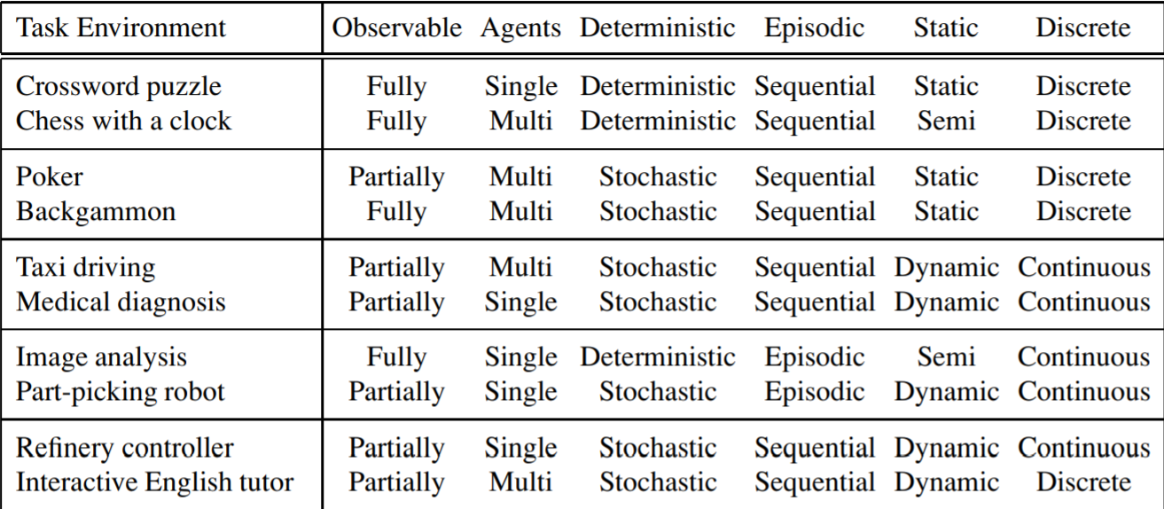**Task environments (Read all the headings before seeing):**

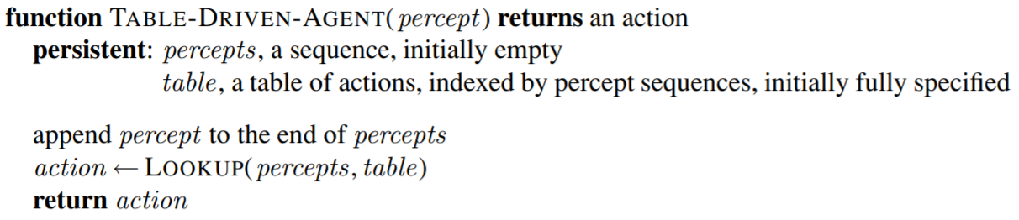**General Agent Function:**

**Schematic Diagrams of different kinds of agents:**

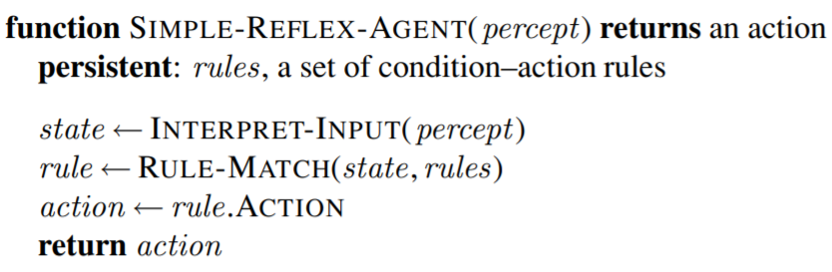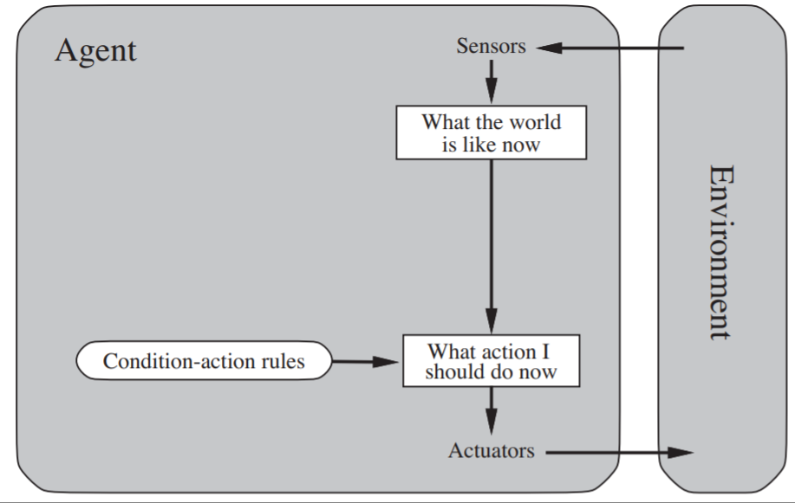**Simple Reflex:**

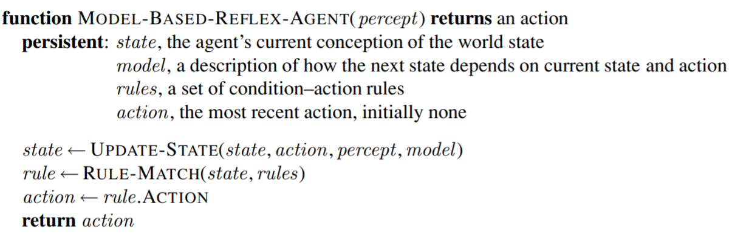**Model Based:**

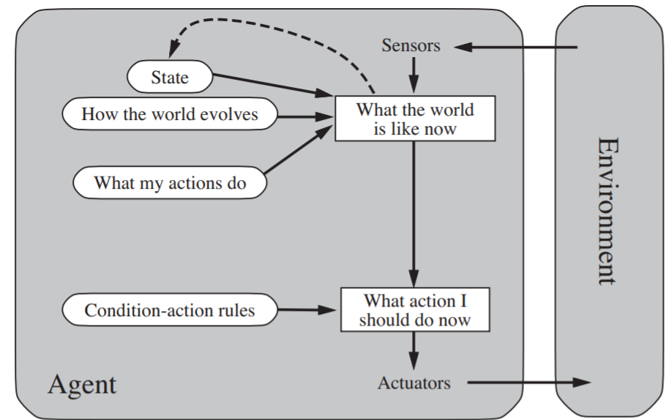

**Goal Based agents:**

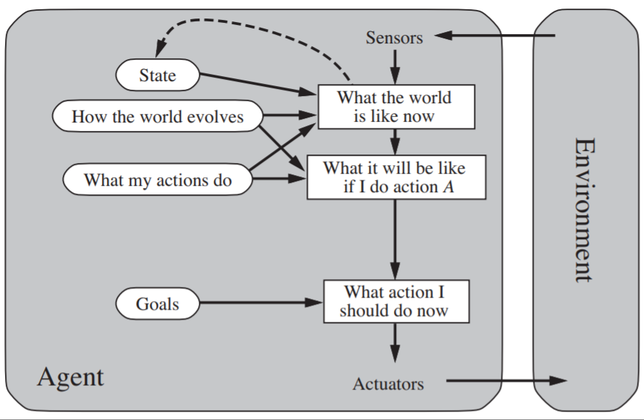

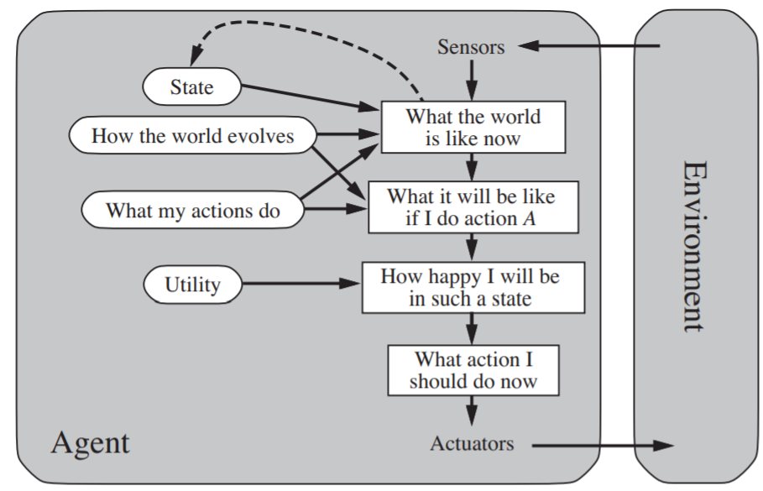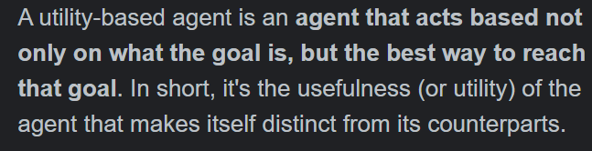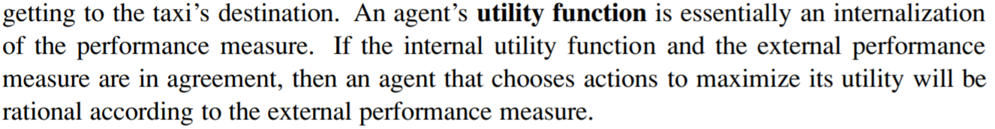**Goal Based A** **gents:**

**Learning agent:**

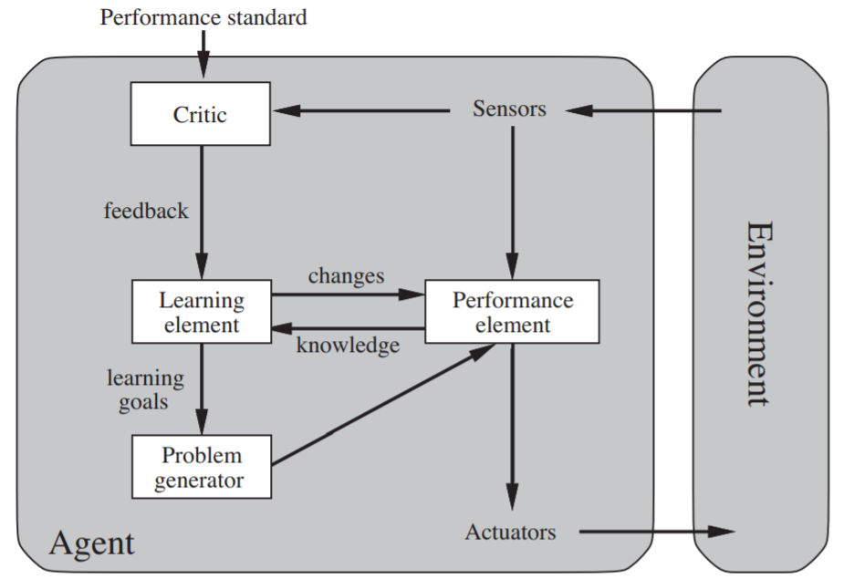

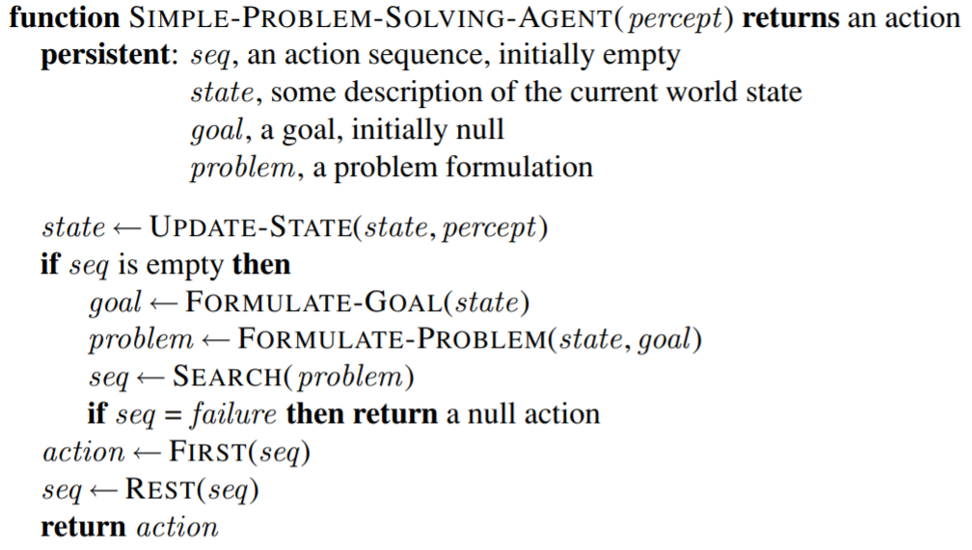**Simple problem solving agent:**

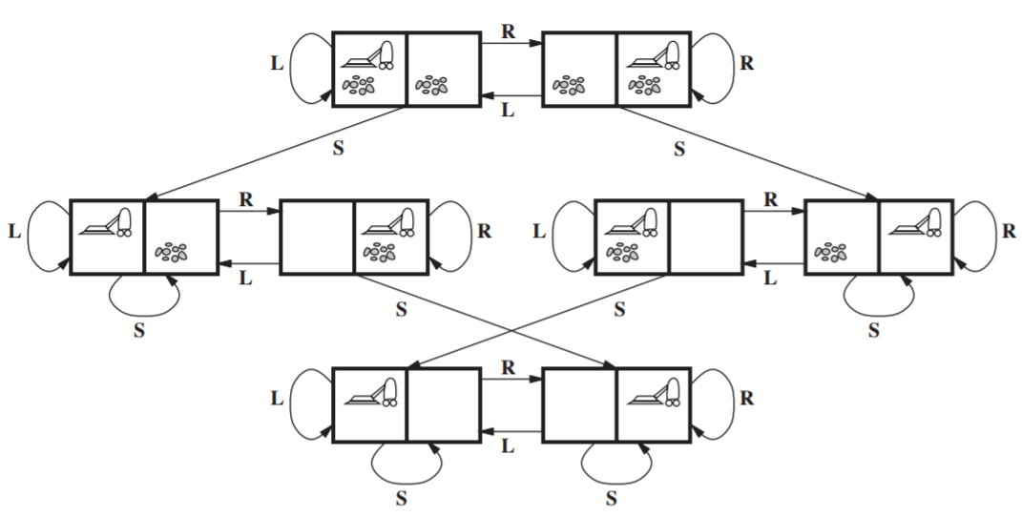**State space of vacuum world:**

**8 queen’s problem solution:**

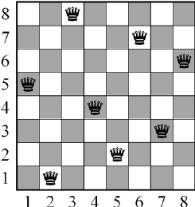

**Tree search (I guess):**

The set of all leaf nodes available for expansion at any given point is called the frontier.

The process of expanding nodes on the frontier continues until either a solution is found or there are no more states to expand.

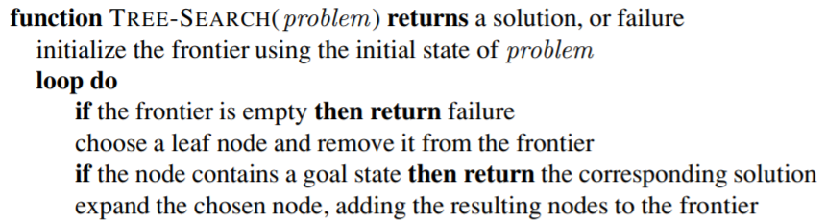**Tree Search Algorithm:**

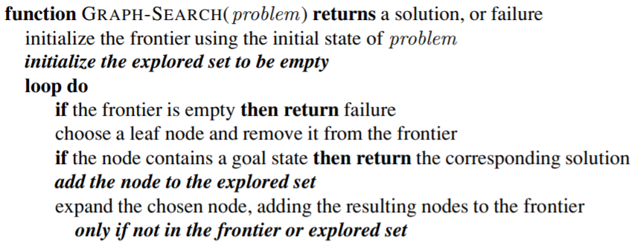**Graph Search Algorithm:**

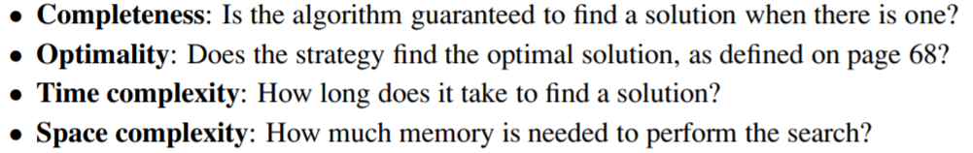**Performance is evaluated by:**

**BFS Algorithm:**

(Uses FIFO -> Queue)

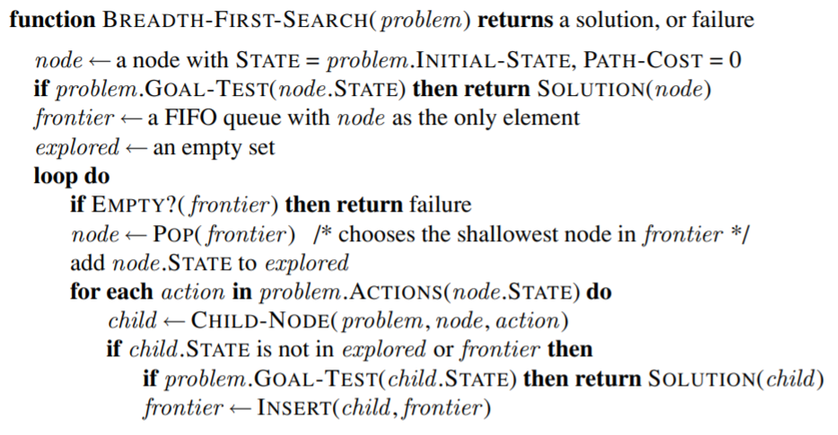

**Uniform Cost Search Algorithm:**

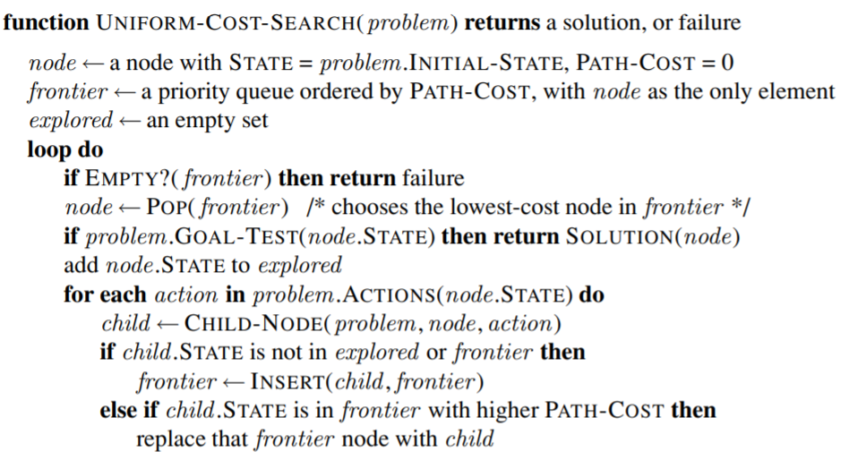The cost is uniform for each path. Instead of shallowest node, it expands the least cost path g(n).

**Depth Limited Search:**

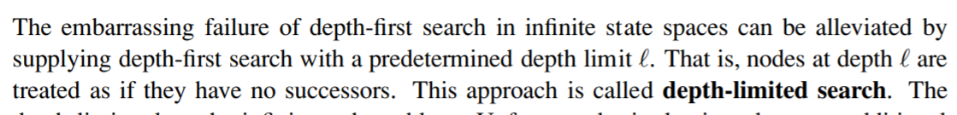

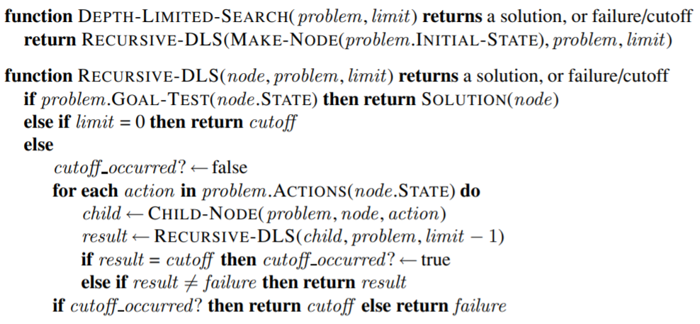

**Iterative Deepening DFS:**

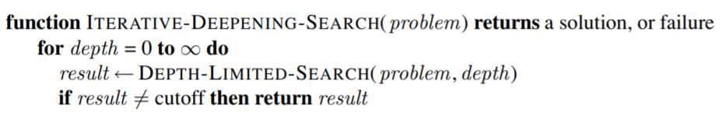

**Comparison of the algorithms:**

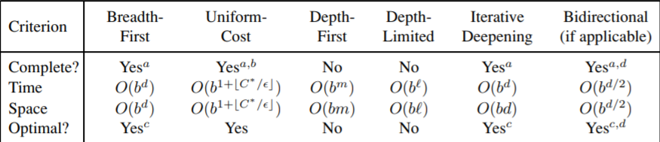

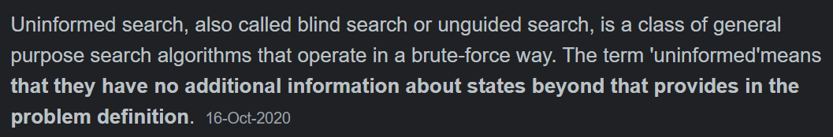All the above ones are **Uninformed search strategies** which mean:

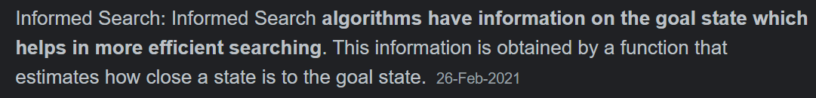**Informed Search** means:

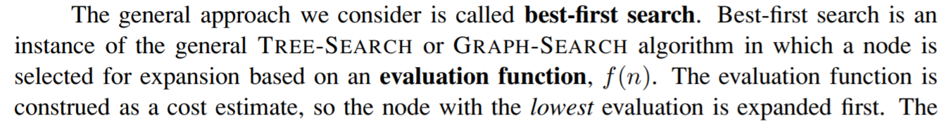**General one is called best-first search:**

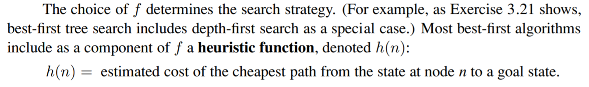**Heuristic function:**

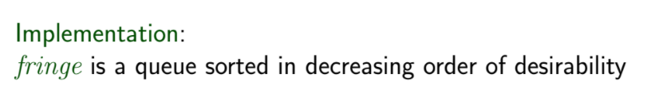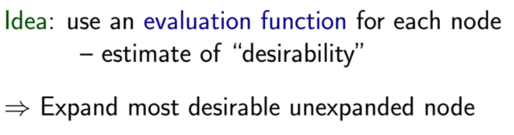**For best-first search:**

**Greedy Best-first Search:**

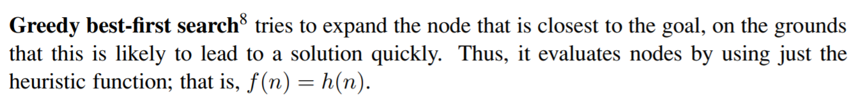

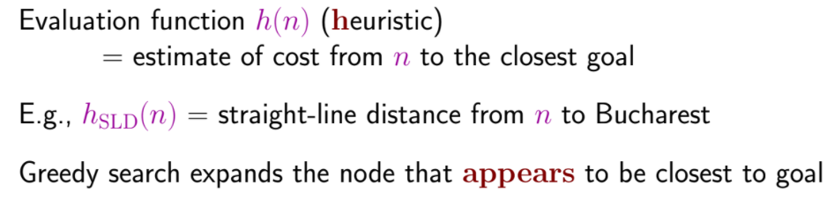

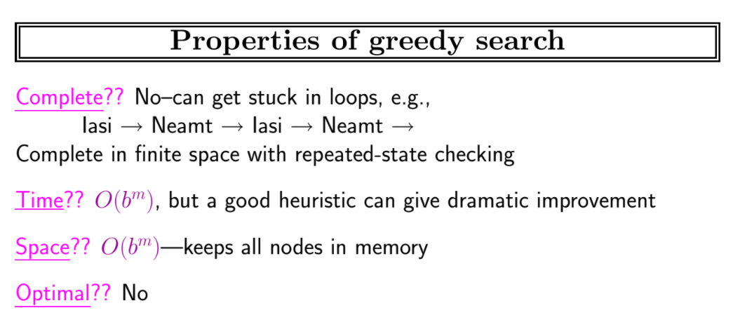

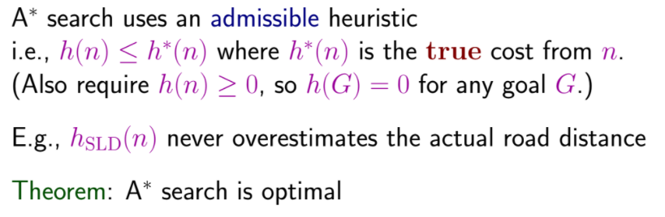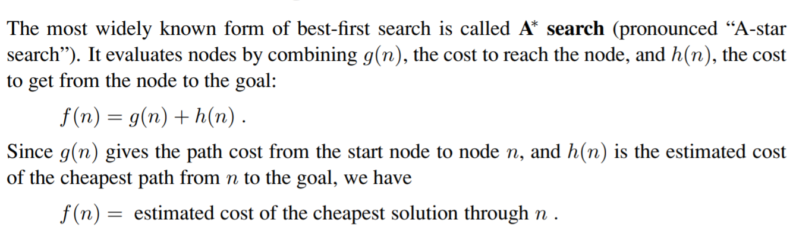**A* search:**

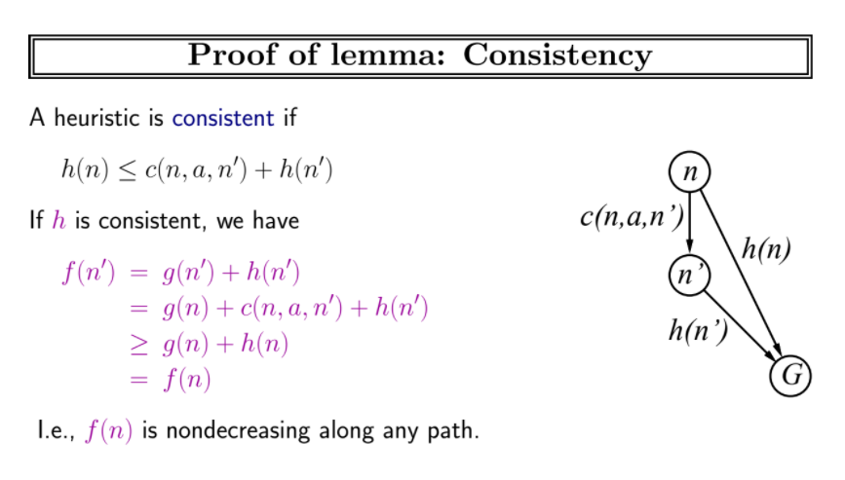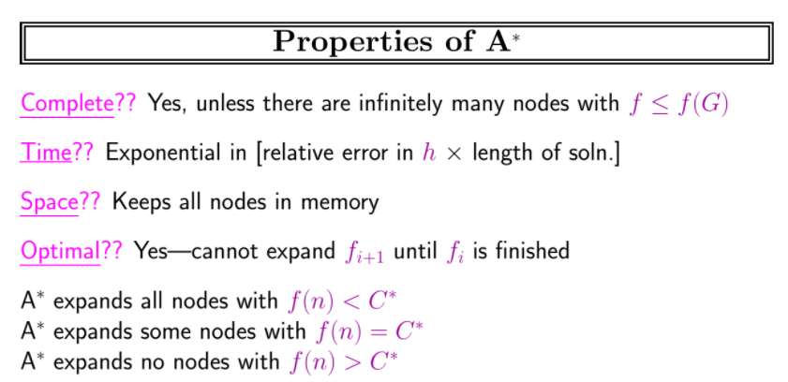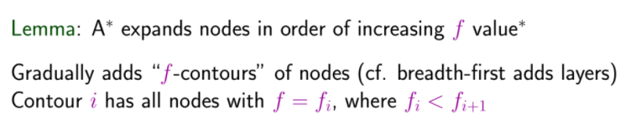

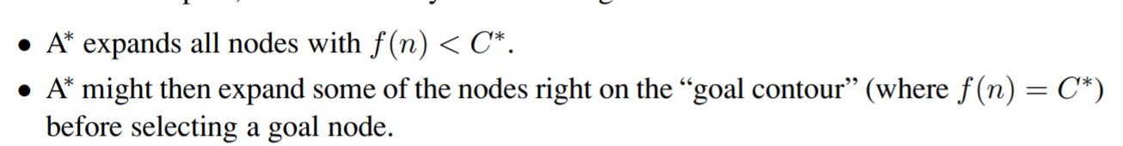If cost of the optimal solution path is C*, then:

**Recursive best first search algorithm:**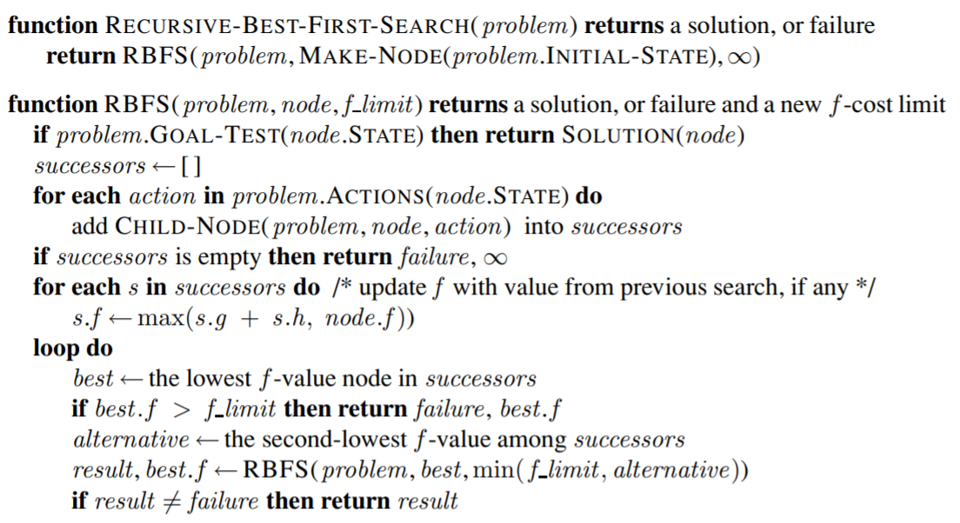

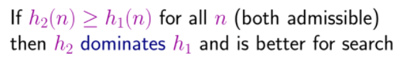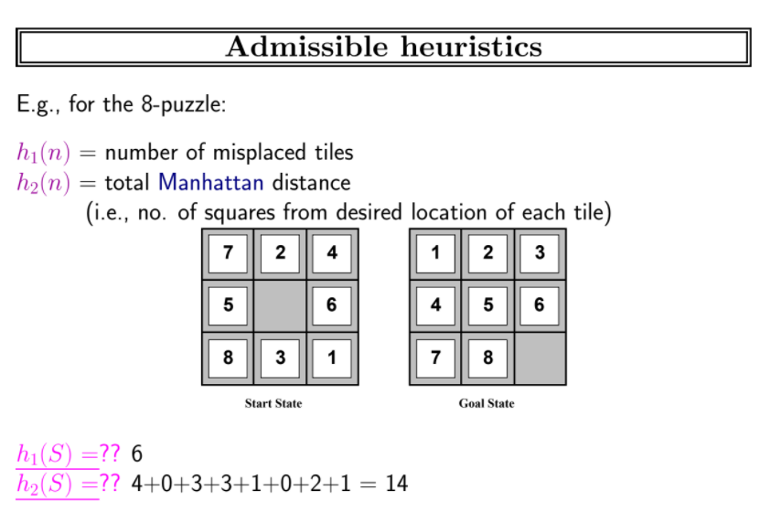

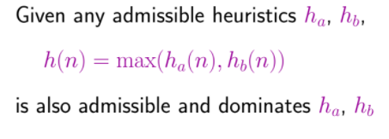

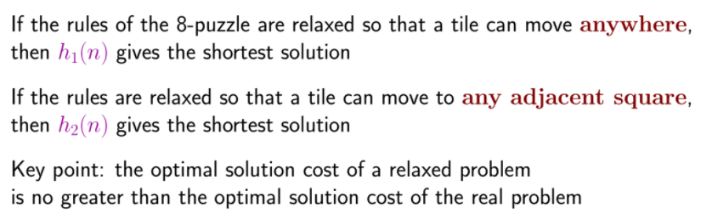**Relaxed problem:** The problem with fewer restrictions on the actions is called a relaxed problem.

**\*Read page 127 of pdf for Summary!!!!\***

**For more A* information, please read the following** [**link**](https://classroom.google.com/c/NDUxNDcyNjYyNjAw)**!!**

**Local Search Algorithms:**

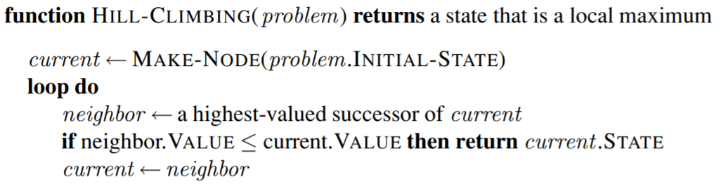**Hill Climbing algorithm:**

Hill climbing is sometimes called greedy local search because it grabs a good neighbor **GREEDY LOCAL SEARCH** state without thinking ahead about where to go next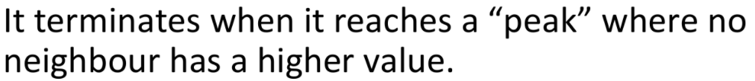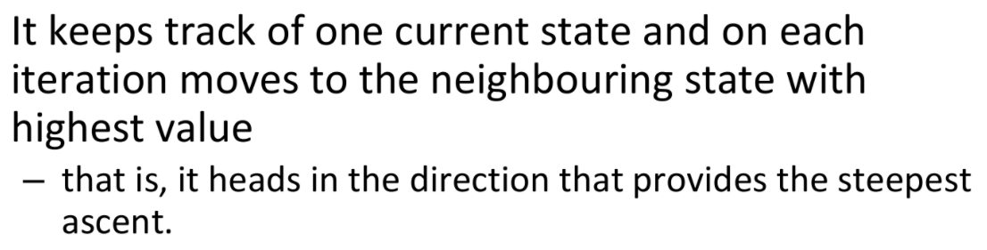.

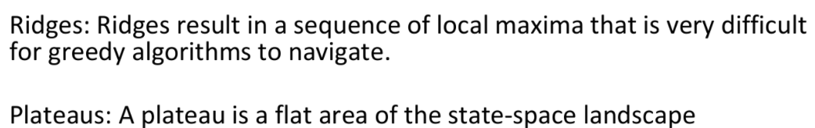

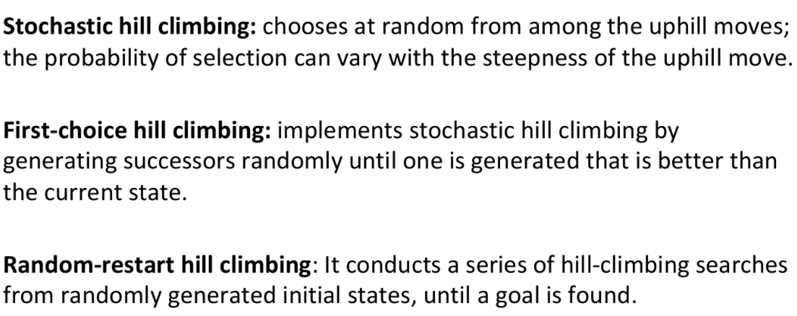

**Simulated annealing:**

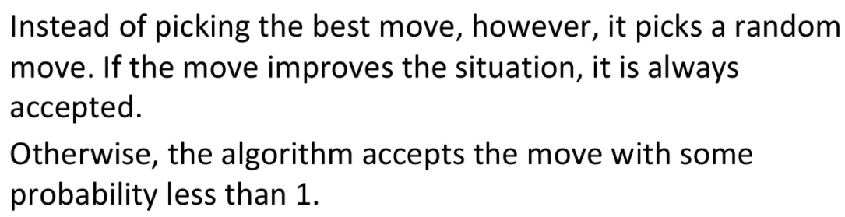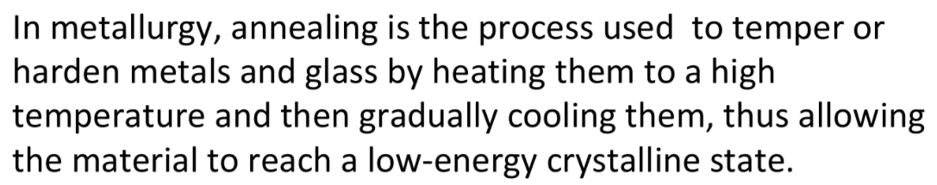

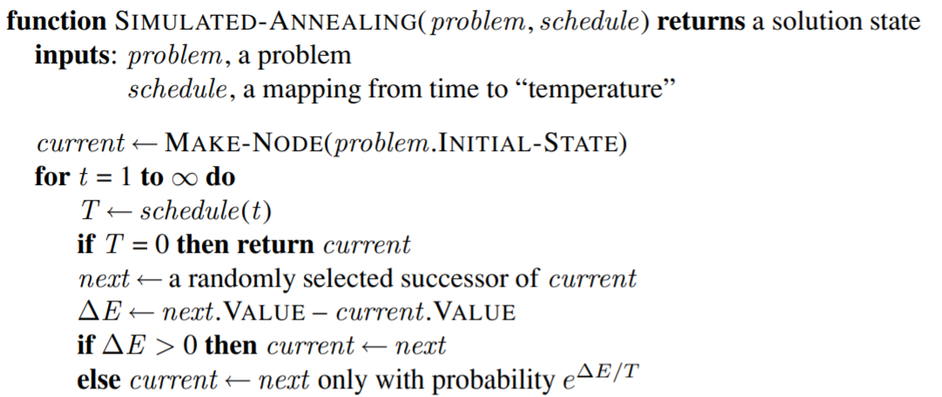

**Read slides for this.**

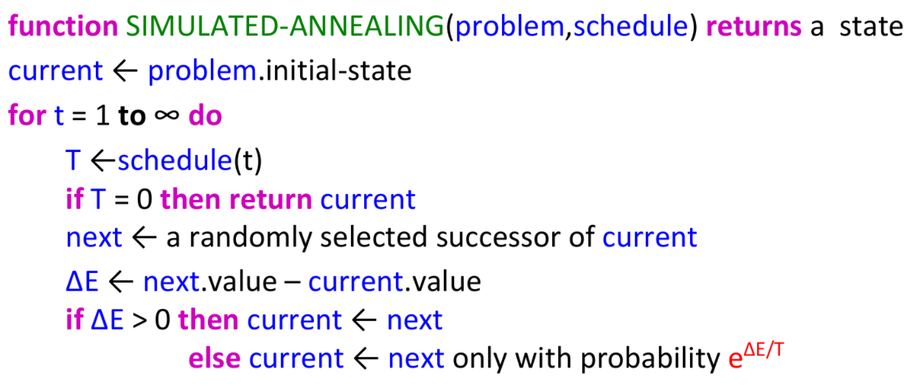**Local Beam Search:**

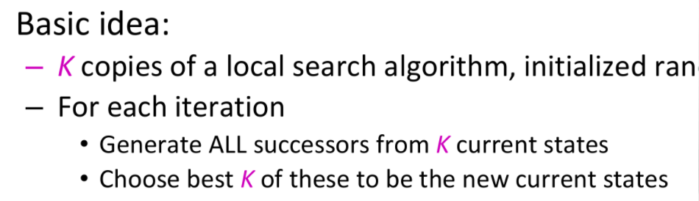

Keeping just one node in memory might seem to be an extreme reaction to the problem of memory limitations. The local beam search algorithm3 keeps track of k states rather than just one. It begins with k randomly generated states. At each step, all the successors of all k states are generated. If any one is a goal, the algorithm halts. Otherwise, it selects the k best successors from the complete list and repeats.

**Genetic Algorithms:**

A genetic algorithm (or GA) is a variant of stochastic beam search in which successor states are generated by combining two parent states rather than by modifying a single state.

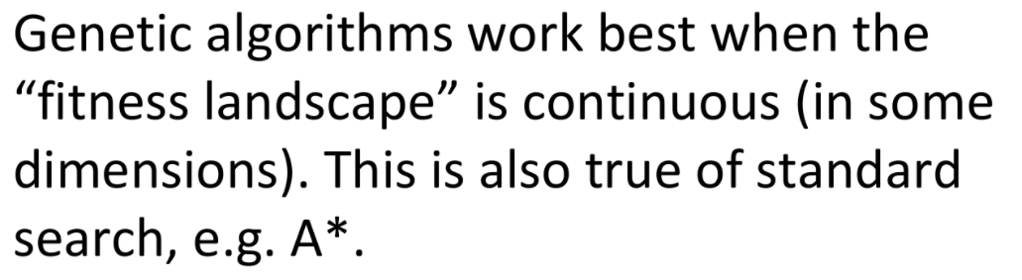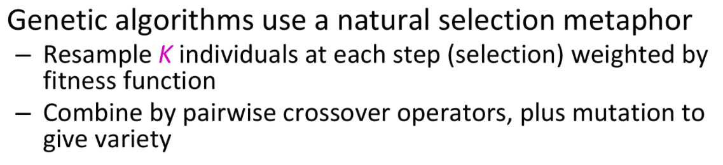

Genetic algorithms are a randomized heuristic search strategy.

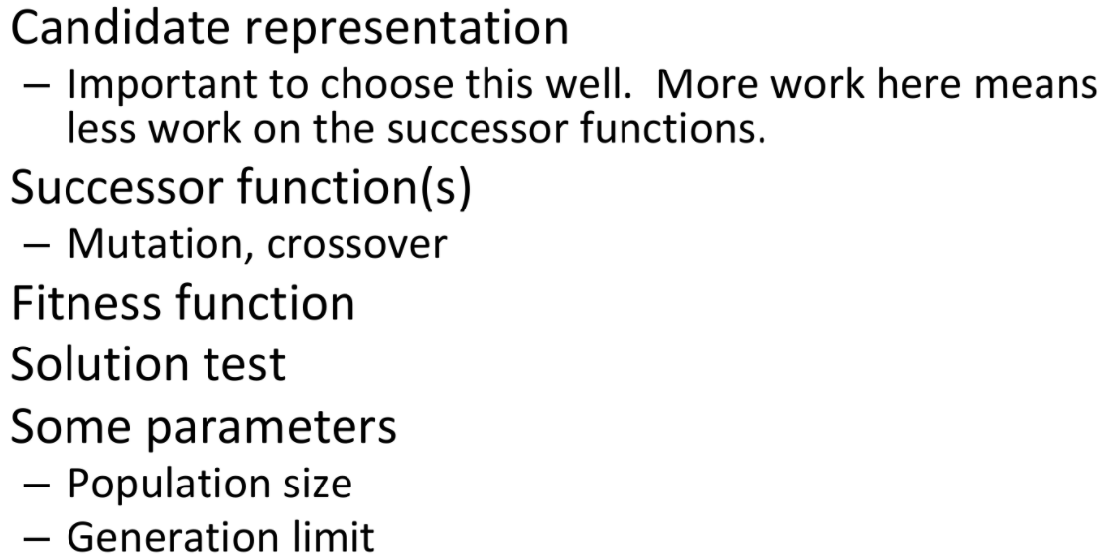**Basic representation:**

**\*Didn’t cover genetic Algorithms! \***

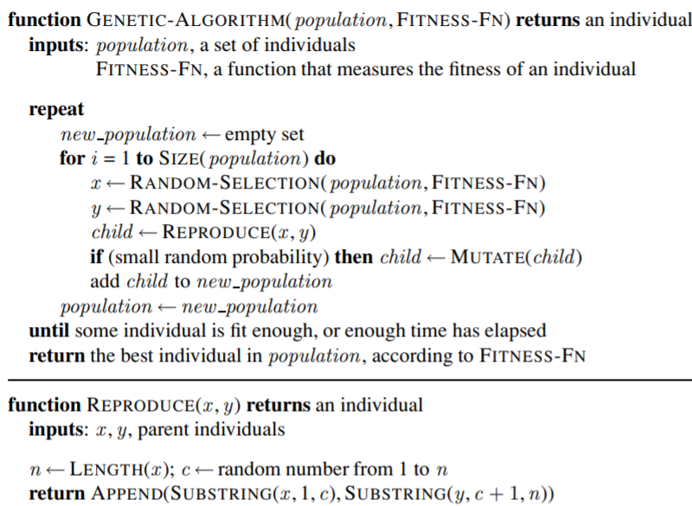

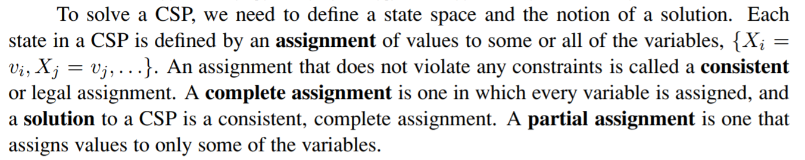**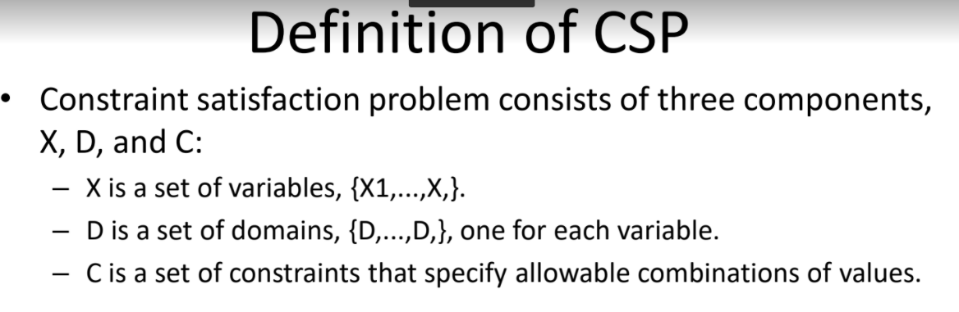Constraint Satisfaction Problems:**

**Solved examples: Refer the solved examples pdf**

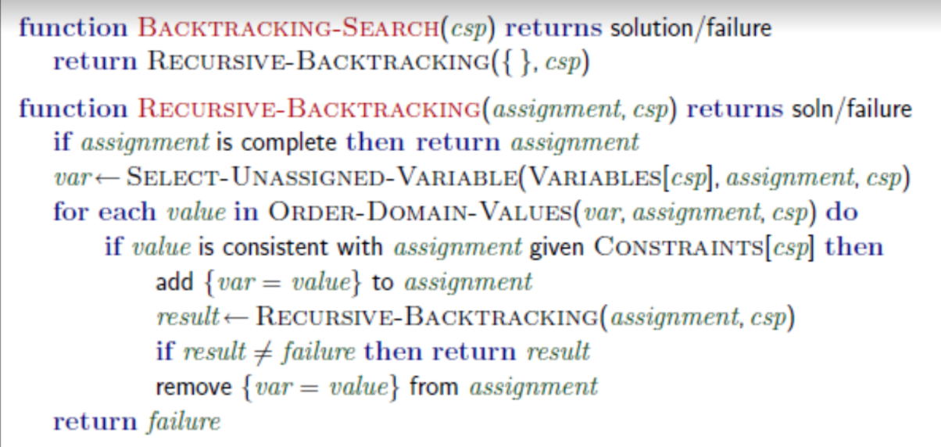**Backtracking Search:**